AIM

This document sets out the AAO’s project management standard operating procedures (SOPs). They are to be followed by all AAO staff involved in instrumentation projects.

The purpose of the SOPs outlined here is to ensure that projects are executed with minimum risk and maximum probability of achieving the project goals while enhancing the reputation of the AAO.

This SOP is to be used for guidance and direction when initiating and executing project work. These procedures will be reviewed annually and critique, aimed at improving the effectiveness and efficiency of AAO operations through improvement of these procedures, is welcome from all users.

The application of these SOPs is intended to move the AAO towards best practice and they are based on the Project Management Institute Body of Knowledge (PMBOK) available on our local web.

CHANGE RECORD

ISSUE | DATE | SECTION/PAGE AFFECTED | REASON/REMARKS
1.0 |  | ALL | First Issue

PERSONS AFFECTED

All AAO staff working on approved AAO projects.

POLICY

The policy of the AAO is to use good Project Management practices to ensure that:

- The work undertaken by the AAO is formally initialised to enable it to be properly executed with minimum financial risk to the organisation or loss of reputation.
- All project work is properly directed at the accomplishment of approved science goals.
- Best practices are applied and reviewed periodically to ensure that they remain relevant, are effective, efficient and make best use of resources to achieve the AAO’s strategic goals. This policy is expanded in PMPol_01.
- All Project Management Policy will be supported by written documentation in the form of Standard Operating Procedures and Work Instructions and these will be subject to review as stated above.

DEFINITIONS

Project Manager - The person nominated by management to manage specific projects or project work programs.

Resource Centre Managers - The line managers of the functional centres, who house, develop and administer the AAO resources on a discipline (Mechanical, Electronic, Software, Instrument Science etc) basis.
Risk management - the culture, process and structures that are directed towards the effective management of potential opportunities and adverse effects, see Risk Management overview figure below.

Capacity - is a measure of our available human resources for allocation to project work. This capacity is drawn from the Resource Centres and a record of future capacity is to be maintained with reference to the emerging work program by Resource Centre Managers.

Demand – the workload that derives from the schedules is the resource demand and this will vary with the program and the nature of the work. The demand is generated by the work programs, negotiated with the Resource Centre Managers and is then managed by the PMs. The outcome of balancing Demand and Capacity is the forward work program.

Matrix Management - The AAO adopts a form of Matrix Management. This is a structure in which the project manager generally shares responsibility with functional managers for assigning priorities and for directing the work of individuals assigned to the project.

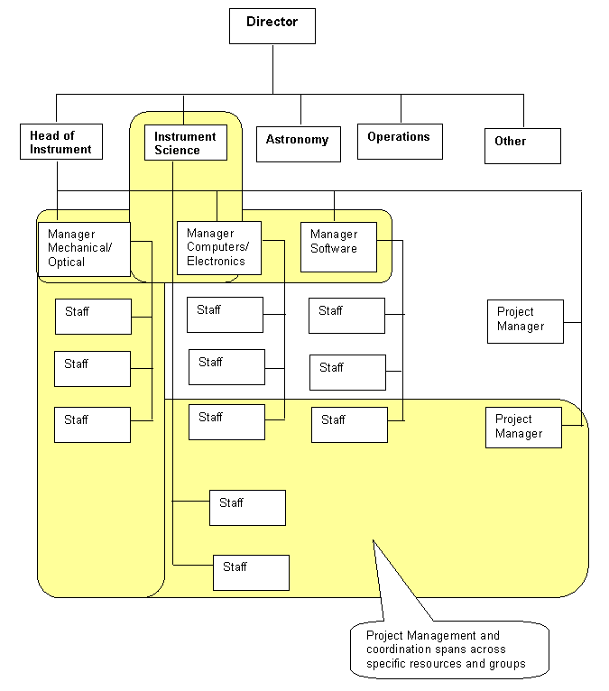

This diagram shows a typical matrix organisation arrangement.

RESPONSIBILITIES

The Head of Instrumentation is responsible for the preparation and maintenance of the procedures to guide and control all project work undertaken by the AAO. The primary responsibilities of the Project Management staff are to:

- Prepare and maintain policy for the execution of all project work to be confirmation by the Director.
- Prepare and maintain standard operating procedures (SOPs) for the conduct of all project work.
- Identify skills and competencies required by the organisation to carry out work in accordance with the local SOPs.
- Arrange training for all staff to enable proper operation of all project management systems and procedures.
- Provide guidance for all operating areas to enable proper adherence to contractual obligations.
- Maintain a forward work program, which identifies the major objectives of the AAO projects and provides plans, schedules and identifies resources to meet the overall objectives.
- Provide general management for all active projects.
- Provide reports to the AAO Director on all active projects.
- Provide input and advice on all projects in prospect.

PROCEDURES

Project Teams

Each project will be assigned a project manager, a project scientist supported by a project coordinator/engineer as required. AAO instrumentation projects also have a site liaison officer and a commissioning scientist. Their roles, and the roles of Resource Centre Managers are spelled out more fully in the Management section of the AAO local web. The current listing of Project Responsibilities will also be available on the local web and maintained by the Instrumentation Group.

7.2 AAO Planning Cycle

The overall AAO planning cycle provides the context in which AAO project planning process sits.

The top level of the planning and budget cycle is the corporate plan, which usually covers a five-year period and sets out the AAO’s broad goals and strategic directions.

Each year the AAO’s work plans and project plans define the budget. The financial year starts on 1st July and the AAT Board (AATB) formally approves the budget at its March meeting, three months before the start of the financial year. This means the budget bids have to be put together in January and February, with the work planning process a little in advance of that.

Project plans evolve all the time but for internal projects, the AAO User Committee exercise in June might be regarded as the concept definition review phase. A project would only appear in the budget after AAOUC and Board approval, i.e. in September. As the budget for that financial year would already have been approved, and a quarter spent, projects approved by the Board in September would not normally reach the construction phase, with the associated large expenditure, until at the earliest, the following financial year.

External projects pass through a similarly formal concept definition phase, but may not necessarily be tied to approval at the AAOUC meeting in June.

The AAO operates a common human resource pool, from which project staff resources are drawn.

The three-monthly AAO project meeting provides an opportunity to review progress in all projects and re-consolidate AAO resources in the light of progress made in all active projects. The AAO Planning Cycle is shown below; new projects can however be approved out of this cycle by arrangement between the Director and Board.

AAO Project Life Cycle

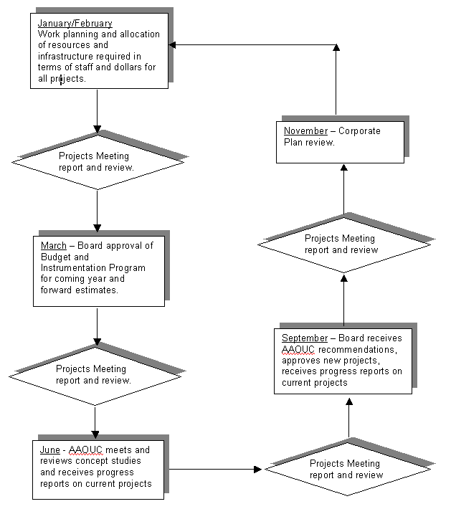

Project are to be planned in phases to provide a logical sequence, management control and to enable review of progress and accomplishment and also to provide escape points if the project is posing a threat to the AAO in terms of technical failure (quality) or serious cost and time overruns that can not be corrected or tolerated.

These generic phases and their inter-relationship are shown schematically in the Project Life Cycle diagram below. Some projects may vary according to the nature of the work scope, size and customer requirements.

The generic AAO Project Life Cycle

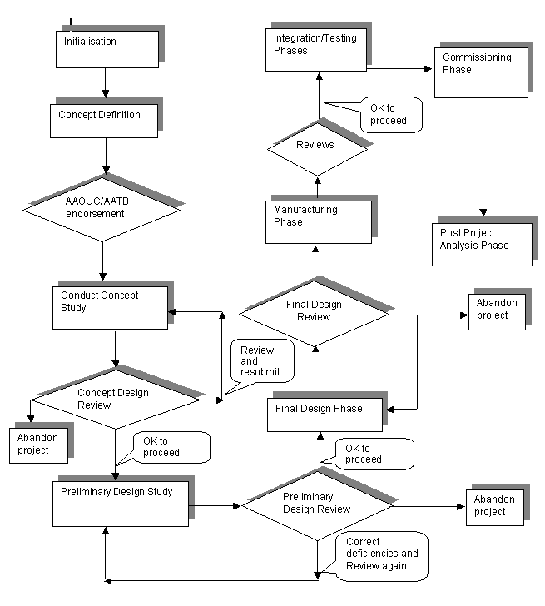

Each phase should end with a deliverable as well as offering an opportunity to measure project performance to that point in time.

7.3 Small or specific project types

The above generic approach is to be amended for smaller projects and for specific types of projects such as Concept Design Studies. For Design studies the project cycle can be truncated, for low cost projects the control overheads are to be minimised and initialisation can be tailored to meet the need.

All projects with an estimated cost (or contract value) of more than AUD 50,000 are to be properly initialised.

8. MANAGING THE PHASES OF A PROJECT

Initialisation

The initialisation process is carried out by a project manager designated by the Head of Instrumentation together with the appropriate project scientist allocated by the head of Instrument Science.

This is the first step to be taken when a project in prospect is defined and is tested against criteria to determine if it is to proceed. The initialisation is to address the science case, the proposed concept, be described in terms of project scope, tested against a set of filters approved by the AATB and is subject to a Risk Assessment.

The output or deliverable is a Concept Definition Report that will provide the basis for the project to move to the next stage.

The Initialisation procedure is described in detail in WKINST_03.

Concept Design Phase or Design Study

This phase provides a concept design or Design Study report. The major focus is on assessing feasibility of concepts and translating user requirements into a functional specification. Then producing a Concept Design Study report of a Concept Design and setting the basis for approval to proceed to Preliminary Design phase

The management structure required for the project is confirmed at this point, see xxxxx.

The output or deliverable is a Concept Design Report or a Concept Design that will provide the basis for the project to move to the next stage. Risk and feasibility are key considerations.

The Design Study procedure is described in detail in WKINST_09.

The Risk Management procedure is described in detail in WKINST_07.

8.3 Preliminary Design Phase

This phase develops the concept design into a Preliminary Design. Functional and Technical specifications are very much in focus, the scope of work, documentation and supporting schedules are under change management.

At the completion of the Preliminary Design phase a review is conducted (PDR). This review is conducted by a panel of experts drawn from the scientific and engineering community for the express purpose of bringing independent critique to the design.
The review aims to establish the compatibility of the preliminary design with the technical specification. The design approach is critiqued and technical risks associated with the instrument to be developed are identified and reviewed on a technical, cost and schedule basis.

The PDR should take place when the hardware specifications are firm and the software top-level design documents and their corresponding verification/test plans are available. In complex situations or areas of high risk and complexity, a prototype may be required.

The output or deliverable is a Preliminary Design Phase report that will provide the basis for the project to move to the next stage. Risk and customer feedback are key considerations

The Preliminary Design Study procedure is described in detail in WKINST_09.

The Risk Management procedure is described in detail in WKINST_07.

8.4 Final Design Phase

This is the final phase prior to manufacture and so design details are finalised and the design is proved. This phase does not deliver the final manufacturing drawings necessary to manufacture the instrument.

The review is conducted by a panel of external, qualified people when the design has reached a final stage and immediately prior to moving to the manufacturing stage. The FDR is a formal technical review of the final design of a development item. The review panel ensures that the detail design solutions as reflected in the engineering drawing set, interface design documents and other relevant documents satisfy the requirements established by the hardware technical specification and computer software top level design documents.
At this time the user requirements are clearly understood, the functional and technical specifications are now frozen and the scope of work to be executed after the FDR approval is clear and fixed. In complex projects it is reasonable to phase the components of the Final Design Review to reflect the various disciplines and functional areas within the project.

The output or key deliverable is the Final Design Study report and approval to proceed to manufacture.

Test and commissioning plans are now established in draft form.

The Final Design Study procedure is described in detail in WKINST_09.

8.5 Manufacturing Phase

This is the production of the instrument proper. The output from the first part of this phase is manufacturing details in the form of drawings and specifications in sufficient detail and accuracy to enable manufacture by AAO internal or external private manufacturing organizations.

At an early point in this phase a manufacturing plan is produced. This identifies what is to be made and when from the schedule and identifies who will make it and at what cost if the item is to be contracted out.

At the end of manufacturing, all those components and assemblies that are required to deliver the working instrument are available and have been subject the necessary quality checks such that the probability of malfunction or failure to function in accordance with the design objectives is minimal.

8.6 Integration and Set to Work Phase

This phase of a project is when the various major component assemblies and major parts from the various groups and sub contractors are integrated. Integrating hardware, software, personnel, facilities and procedures pulls the instrument together.

Checks are made applying quality control to ensure the end result is achieved with the minimum of duplication, redundancy and waste.

At the end of integration the instrument has been proved as an assembled entity and has been subject to quality tests, which provide assurance that the instrument will perform and has a high probability of meeting the specified performance. The testing phase takes this further. Essential documentation should be progressed and/or completed and facility needs confirmed prior to moving to testing.

The deliverables are an integrated instrument that is ready for the Test Phase together with a set of Test Plans and acceptance criteria.

Commissioning plans are now finalised and agreed with the customer.

8.7 Testing Phase

During this testing phase (test, tune and set to work phase) the instrument performance is proved under operating conditions that duplicate the target-operating environment.

A pre-defined testing program is used to establish the performance by measuring a range of operational characteristics. The test results are measured and compared with target operating performance and any variances are identified and analysed.

The key deliverable is the instrument test report and approval to proceed to Commissioning.

8.8 Commissioning Phase

The instrument is set to work in the operating environment. At completion of the commissioning phase the instrument is operating in its design mode or in the case of any variances, in a mode that has been agreed with the customer or end user and is now able to gather the data required and specified in the agreed or contracted specification for the instrument.

Major projects will have a Commissioning Scientist who assists the Project Scientist to plan, organize and direct the commissioning phase. This includes establishing test procedures prior to and during on-sky commissioning, full resourcing of the work, collection and analysis of the commissioning data and delivery of the commissioning report.

The key deliverable is a commissioned instrument accepted by the Project Scientist or the customer’s representative.

8.9 Post Project Analysis Phase

On completion of the above phase a meeting is initiated by the project manager to determine how well the organization performed and to establish prioritized areas for improvement and future action.

On completion the project is closed out by informing management of key findings from the project management process that can be transferred to other projects.

9. PLANNING AND SCHEDULING GUIDELINES

9.1 Planning

The process of planning will be managed by the project manager and will address the full scope of work, set direction and establish means to check progress along the way.

Sufficient detail will be put into the process to enable control and manage budget and risk.

The AAO accounting system is to be used to facilitate cost monitoring and control of costs.

The steps for Planning are described in the Work Instruction for Project planning and Estimating WKINST_04.

9.2 Scheduling

The project manager will produce a work schedule comprising resource, control and milestone detail as early as possible in the project cycle; its detail and accuracy increase as the project evolves. The essence of the project schedule is a list of all the tasks, the work involved in each task, and an indication of which tasks are contingent upon another.

The schedule is the authority to incur expense and so work should not be undertaken unless it is on the schedule.

See the Work Instruction for Use of the PM scheduling tools WKINST_02.

10. PROJECT SCHEDULING TOOLS

10.1 Standard scheduling software

The AAO has standardised on Microsoft Project (at the time of writing Standard 2002 (10.0.2002.0502)) as its project management software and on the use of a template Gantt chart.

Details of how to operate the AAO standard scheduling system are maintained and these can be found in the Work Instruction WKINST_02.

10.2 Using Pooled Resources and Consolidation of Plans

AAO Resource Pool

A pool of resources for project work is to be maintained. This consists of a list of all people (at Epping and at Site) identified to work on instrumentation projects and how much of their time, expressed and a percentage availability over the year, is available for project work.

The Project Office will maintain the pool and any additions are to be introduced through the Project Office.

These resources exist in a specific form and will be identified to support the budget process.

Details of how to maintain and operate the AAO Resource Pool can be found in the Work Instruction WKINST_01.

Consolidation of Project Plans and Resource Analysis

This process allows the AAO to establish the load on each resource described in the AAO Resource Pool. The Head of Instrumentation and the Project Office conducts a formal review at three monthly intervals (to coincide with the AAO projects meeting). A regular review of resource issues will be conducted at periodic Instrumentation Meetings.

An aim of consolidation is to reflect the current AAO priorities and enable adjustment of task planned dates to achieve the best balance the workload while maintaining the key deliverables to be achieved at the milestone dates set.

Details of how to conduct Consolidation and Resource Analysis can be found in the Work Instruction WKINST_01

11 RISK MANAGEMENT

The management of risk is an essential component of the Project Management system. As early as the initialising phase, risk is to be determined by the conduct of a Preliminary Risk Assessment and the establishment of a Risk Register.

Risk assessments are to be progressive and the maintenance of a Risk Register is essential for all projects. The detail and the extent of the risk management techniques applied is to be determined by the nominated Project Manager and will reflect the value of the project and its strategic importance to the AAO.

Details of how to conduct Risk Management can be found in the Work Instruction WKINST_07

12 MANAGEMENT OF CHANGE

Change in terms of scope or delivery variations can threaten project goals and cause a failure to meet customer or contractual expectations.

The management of change is important and will be handled formally by the responsible Project Manager on each project undertaken by the AAO. The effort (time and cost) allocated to this process must be determined on the basis of risk.

The Head of Instrumentation will nominate which projects are to be regarded as "major"; the change management process for these is more formal than for other, minor projects.

12.1 Major Projects

Major projects should have a Change Board, which will comprise of the Project Manager, the Project Scientist and Functional Managers as required and called on by the core team (Project Manager and Project Scientist).

The Change Board will oversee changes in scope and/or objectives. The role of the Change Board is shown in the attached example.

12.2 Minor Projects

Minor projects would follow the same principles but less formality directed by the Project Manager. Notes should be kept of all changes and the scope of matters reviewed would be the same as for major projects but the level of effort must reflect the risk and cost of operations.

Details of how to conduct Change Management can be found in the WKINST_04

13. MONITORING AND REPORTING ON PROGRESS

13.1 Overview

Aside from the major project milestones, the AAO regularly monitors the progress at a number of different levels:

- Regular monitoring at work package or section level
- Monthly Project Progress Meeting
- Three-monthly AAO Projects’ Meeting
- Annual AAO User Committee/AATB

Within the various projects, the work packages will be arranged to allow good management and the use of Work Package Managers.

13.2 Regular monitoring

Designated work package managers make regular checks, probably weekly, on how things are going. The basis of this approach will involve all team members and require that a brief review of the things to be done that week.

From time to time, the PM may call the team to meet to solve emerging problems and to make changes, or provide more detail, to the plan.

13.3 Progress meetings

The project manager will call a meeting of the work package managers about once a month. Before the meeting, work package managers will update their plans to show progress and the current state of play. At the meeting, the team will jointly review matters and make whatever adjustments and decisions are necessary.

13.4 Projects meeting

Brief (1 page) written reports are submitted to the Projects Meeting (Template A5) but without the spend profile). The aim is to report on progress to the people at the Projects Meeting, not to resolve issues: problem solving should take place within the project teams.

13.5 Resource Analysis and Consolidation

This analysis forms a key part of the AAO’s preparation for projects’ meetings. This addresses the work program resource demands and the balance that has been struck between demand and capacity.

A timetable for the major process is maintained and followed prior to major review meetings.

13.5.1 Consolidation Timetable:

To facilitate the proper input at major project reviews, the AAO will follow a timetable prior to the Projects’ Meeting:

Projects’ Meeting -5 weeks: All work package managers as identified by the Project Manger are to review their current schedule and identify any problems that exist in terms of content, resources and schedule compliance. The work package manager or person nominated as responsible for the Work Package in question provides all matters for attention to the Project Manager (s) in written form.

Projects’ Meeting -4 weeks: An accurate and comprehensive progress report is made through the Project Management progress reporting system. This report does not replace the need to routinely report through the system on a fortnightly basis. See the Procedures for Project Progress Reporting.

Projects’ Meeting -3 weeks: Project plans for major projects are submitted to the Project Office for consolidation. Resource Centre Managers and Work Package Managers are responsible to submit detail concerning their own area of responsibility to their Project Manager. The Project Manager will interact with the Project Office providing project detail in MS Project format.

Projects’ Meeting -2 weeks: Consolidated plans returned to work package managers/project managers for comments/refinement. All work package managers/PMs are to sign off on plan before progress reports submitted to the AAO Project Meeting.

Projects’ Meeting -1 week: A two (2)-page progress report in standard format (Template A5) for all projects is to be submitted to the Director’s PA for distribution to nominated staff prior to project's meeting.

Projects’ Meeting -4 days: Progress reports distributed to staff by Director’s PA.

Details of how to conduct Project Resource Analysis can be found in WKINST_01.

13.6 Project Progress Reporting

The accuracy and content of regular project progress report relies on input from the staff associated with the specific tasks or Work Packages. The Project Manager is responsible for making reports on project progress at the AAO Projects Meeting, which is held at about 3 monthly intervals.

During the period immediately prior to that meeting Resource Centre managers and nominated Work Package managers are to provide input to the Project Manager. The form of the input is similar to the format to be used by the Project Manager - see Template A5. Focus is placed on Status, Issues / Concerns and on any variances they see occurring from the formal plan and in particular the milestone accomplishments. Recommendations for corrective actions to recover schedule or specific changes required to the plan should be identified.

Routine progress reporting is to occur on a fortnightly basis as for time recording. See paragraph 14 below.

13.7 Board & AAOUC reports

The Board receives reports for the major projects on progress against planned milestones. Template A5 should be used for such reports. The Head of Instrumentation presents these reports and gives his own overview. A similar report should also be given to the AAOUC at their June meeting.

14. TIME RECORDING AND PROGRESS REPORTING

All project staff are to make a time and activity report on a fortnightly basis using the current version of the recording sheet (this is updated to reflect the status of the work program from time to time). The report shall include hours worked by task, estimates for completion.
Notes of relevance are to be put onto the form to draw the PM’s attention to problems, growth or other routine matters that require attention.

Reports are to be made on the form provided and sent by e-mail to the Personnel Office and to each Project Manager as identified in the published list of project responsibilities.

Details of how to conduct Time and Progress Reporting can be found in WKINST_08.

15. COST BOOKINGS TO PROJECTS

All AAO project work is to be managed in a manner that allows proper and visible collection and recording of all costs. The need for cost collection is to be taken into account when planning and scheduling project work. The full range of costs to be collected will include labour, sub contract and outsourced work, components, materials, infrastructure, travel and other.

The accounting systems constraints are to be taken into account when planning the details for both budgeting and cost recoding and reporting.

Details of how to conduct cost bookings are to be facilitated are shown in Work Instruction WKINST_12.

16. STANDARDISING PROCESSES – USE OF TEMPLATES

The general processes described in this SOP are to be maintained in simple and standard format throughout the AAO by the use of template documents. The various Work Instructions will contain the templates to be used and will include: -

A1. Project Cover Sheet

A2. Project Scope

A3. Project Filter

A4. Risk Assessment

A5. Progress Report

- REVIEW

The Head of Instrumentation will review this Operating Procedure annually.

- Related Documents

All other PM Policy and SOP documents as listed in the PM document register.

- ISSUED

This SOP is issued on date ********

C G Tinney

a/Director

Appendix

A. Role of Change Board

A1. Project Cover Sheet

Project Cover Sheet

The Project code can act as an index into a project register
Project Code _________ Project Manager ______________________

Project Name _____________________________________

Project Description _____________________________________
_____________________________________
_____________________________________
_____________________________________
_____________________________________

Owner/Sponsor/Client ____________________________________

Project objectives should be specific and measurable. They may also be attached to a timeframe. For example an objective could read: “To double the throughput of orders by December 1998.”
Project Objectives

The deliverable should be a description of a tangible realizable product that can be demonstrated as proof of successful completion of the project.
Project Deliverables

The planned start and finish dates and budget value should be entered once the final plan has been established and the task and schedule calculated.
Planned Start Date _____________ Planned End Date _____________

Direct Costs $_____________ Staff Costs $_____________

A2. Project Scope Sheet

Project Scope

The project scope helps clarify the lines demarcating the boundaries of the project. It is important to be explicit in stating what is to be included and also what is to be excluded. These could relate to geographical, departmental, conceptual or other boundaries.
To be included:

To be excluded:

A3. AAO Project Filters

The Anglo-Australian Observatory's Mission Statement:

The main purpose of the Anglo-Australian Observatory is to facilitate the best possible science through the provision of world-class optical and infrared observing facilities for British and Australian astronomers. It also takes a leading role in the formulation of long-term plans and strategies for astronomy in both countries and, through its research and development of new instrumentation, to the advancement of astronomy internationally.

Project Threshold

Any project valued at A$50k or greater must pass through the following project filters.

Consistency with AAO mission statement

Does the project help to facilitate best possible science to UK and/or Australian communities either through the provision/enhancement of world-class optical and infrared observing facilities or, through the research and development of new instrumentation, to the advancement of astronomy internationally?

Answer must be Yes

Record in details table below.

Benefit to the AAO

Does the project bring either direct scientific and/or technical benefit to the AAO, measured via:

- enhanced collaborations/transfer of scientific/technology IP with other astronomical organisations?
- engagement for AAO astronomers/instrument scientists in major new scientific programs or instrumentation on world-class astronomical facilities?
- development of the scientific or technological IP required to enhance AAO’s opportunities for future engagement in large scientific or instrumentation projects?

Answer must be Yes to the majority of questions

Record details in table below.
Human Resources

Does the AAO have the staff with the necessary skills available to complete the program?

If not, can the AAO
- hire the appropriate skilled staff, or
- train/re-program existing staff, or
- sub-contract work to an outside agency

on a time scale/cost compatible with the project?

Answer to 1st or 2nd question must be Yes

Record details in table below

Infrastructure

Does the AAO have the infrastructure required to achieve the project outcomes within the required time scale:

- Computing requirements
- Laboratory equipment
- Machine Tools
- Design/drafting requirements
- Laboratory and engineering development equipment
- Workshop space
- Office Space

If not, can the AAO obtain the required infra-structure or source externally?

Answer to 1st or 2nd question must be Yes

Record details in table below.

Impact on Existing Program

Can the AAO ensure that the resources required for the project will have minimal impact on existing program.

If not, can existing projects be delayed without damaging AAO’s reputation or core business?

Answer to 1st or 2nd question must be Yes

Record details in table below.
Financial

Is the AAO able to enter into a contact that will either:

- minimise financial risk to the AAO or
- apply level of overhead commensurate with level of risk

Is funding likely to be available to meet the cost of the project?

Answer to all questions must be Yes

Record details in table below.

Management

Can the AAO identify the appropriate management team :

- Project Manager
- Project Scientist
- Project Engineer
- Commissioning Scientist (if required)?

Can the management team successfully discharge the responsibilities attached to these roles in the time scale required?

Can all major risks be identified at the outset of the project?

Answer to all questions must be Yes

Record details in table below.

Customer

Do we understand the customer’s environment and contractual practices, including the ability to pay, sufficiently well to ensure that they pose no major risks to the project?

Can we ensure that interaction with the customer will only add value to the project?

Answer to all questions must be Yes

Record Details in table below

Project Filters: Summary Table

Filter Item | Details | Project Phase
Relevance to Mission Statement
Scientific/Technical Benefit
Human Resources
Infrastructure
Impact on Existing Program
Financial
Management
Customer

Supporting details (add any further comments here):

Signed: ___________________________ Date: ___________________

Project Manager designate

Approved: _________________________ Date: ___________________

Head of Instrumentation/Director.

A4. RISK ASSESSMENT SHEET – template on web at xxx

Risk Management is an essential and continuos process during the project cycle. Initial efforts are directed ate the establishment of a Risk Assessment as shown below. Later the preparation of a Risk Register is carried out and the Project manager will carry out a Risk Watch process. An example of the Risk Register is shown following the Risk Assessment table.

RISK ASSESSMENT

Risk | Probability | Impact on project | Rank /  Priority | Action | Responsible | By Date

Risk Register

The AAO Project Risk Management Guide is on the web at xxxxx

A5. REPORT TEMPLATE – get from web at xxxxx

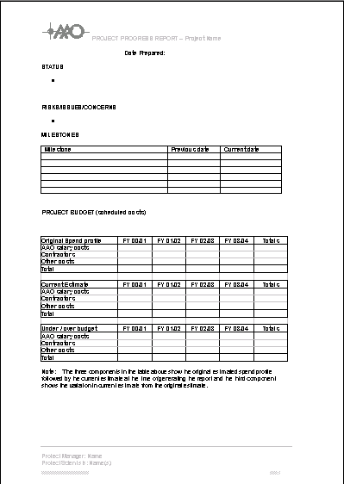

APPENDIX A.

ROLE OF THE CHANGE BOARD

Major AAO projects will be managed for risk exposure and a significant component of risk derives from Change.

The Project Manger will be responsible for the establishment of a Change Board. This will usually comprise of the Project Manager, Project Scientist, Project Engineer and other nominated members off the project team as required by the nature of the changes to be reviewed and determined.

Example of a Change Board is as follows: -

Project: OzPoz

Composition of the Change Committee:

Chris Evans Project Manager
Keith Taylor Principal Investigator
Peter Gillingham Project Engineer
Denis Whittard Configuration Management
Other as determined by nature of change

CONTRACT CHANGE CONTROL - CONFIGURATION BOARD

The purpose of the Contract Change Board/Configuration Board is to oversee all aspects for Change Request and Request for Waiver procedures. See RIQ 207. The board also must review approve/disapprove the Configuration Management Plan, CM procedures, the selection of configuration items, configuration baselines and changes to those baselines including deviations and waivers.

Necessary documents will be maintained using the Request for Change or Waiver form as shown at page 8 of the Configuration Control Plan, - Section 2.3 of the PDR package.

The function of the CB is to verify that:

- It has the correct authority in relation to the relevant configuration baselines;
- The change is necessary
- The consequences are acceptable
- The change has been properly documented and classified
- The plan for the implementation of the change into documents, hardware and or software Is satisfactory

The status of all Change Board actions is to be recorded on the ESO forms as provided and reported to ESO as determined by the contract.

