Importing Offline Projects into MS Project Server

2007/08/28 WNR

- Confirm that the MS Project (non-server version) settings are correct for the project to be imported:

Tools->Options->View should look like:
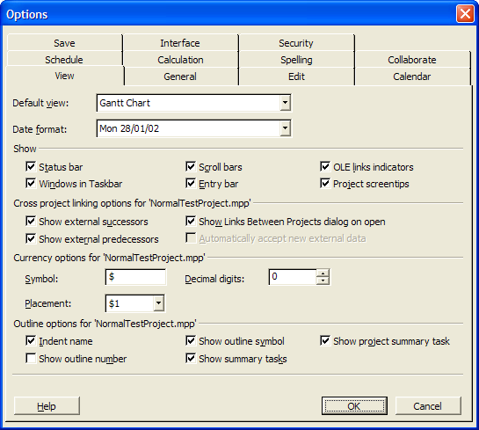

Tools->Options->General should look like:
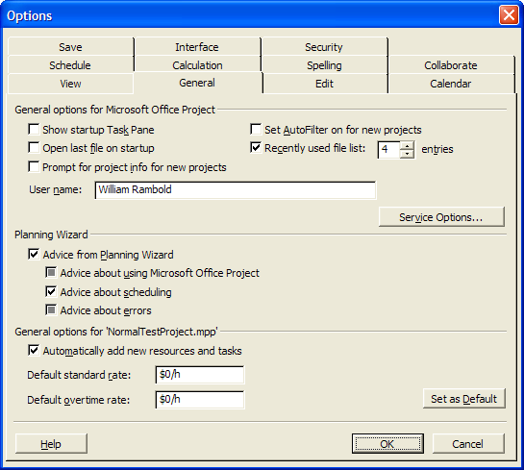

Tools->Options->Schedule should look like:
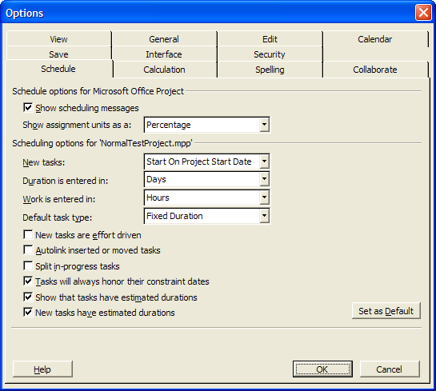

Tools->Options->Calculation should look like:
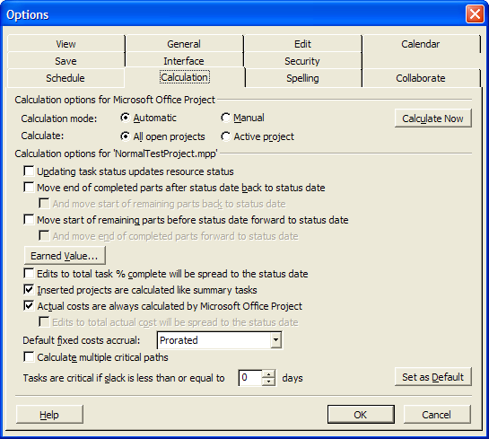

Tools->Options->Save should look like:
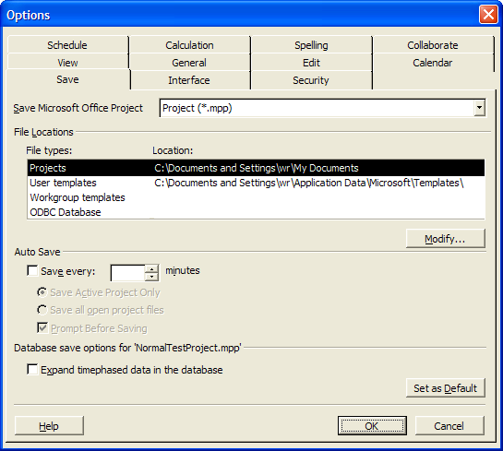

Save the settings and close MS Project.

- Switch to the “AAO-DOMAIN” and insure that the “p:” drive and the “S:” drives are connected by viewing them with Windows Explorer:

P: drive is \\wincenter2\pdrive
S: drive is \\solomon\solomon

- Start MS Project Server and open the project to be imported via the “open from file”button:

Click on File->Open then use the Open from File button…

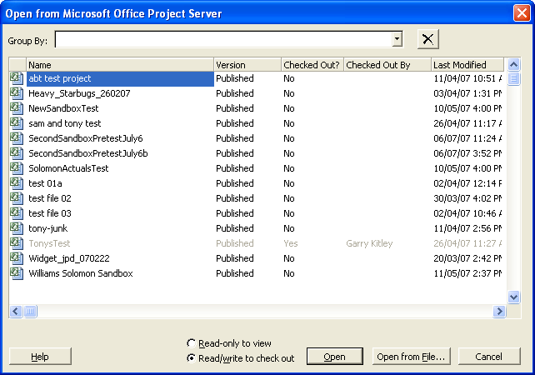

On the Open screen select the file that you are planning to import:
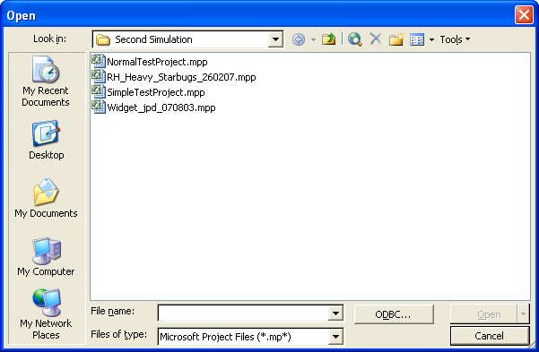

The project should appear… Make sure the display shows WBS, UID, Name, Duration, Work, Start, Finish, and % Complete columns. Also make sure that the top level summary task is visible (WBS 0):

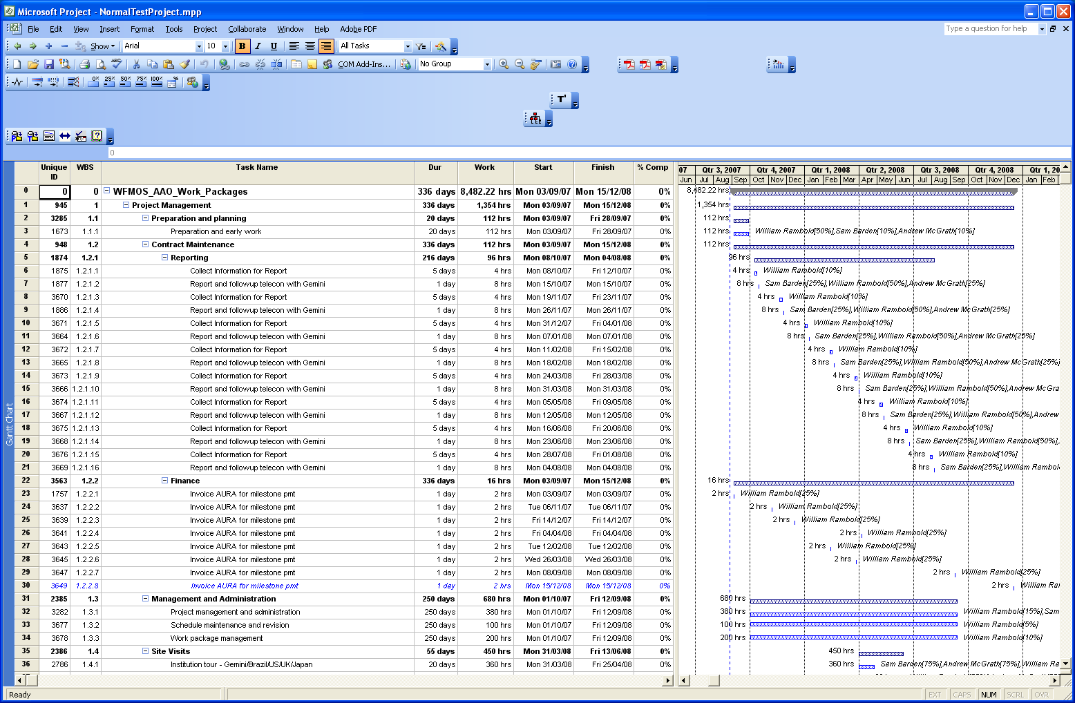

Use the File->Print to print a hard copy for your records. This will come in handy when checking the Solomon Import

Save the project then close it…

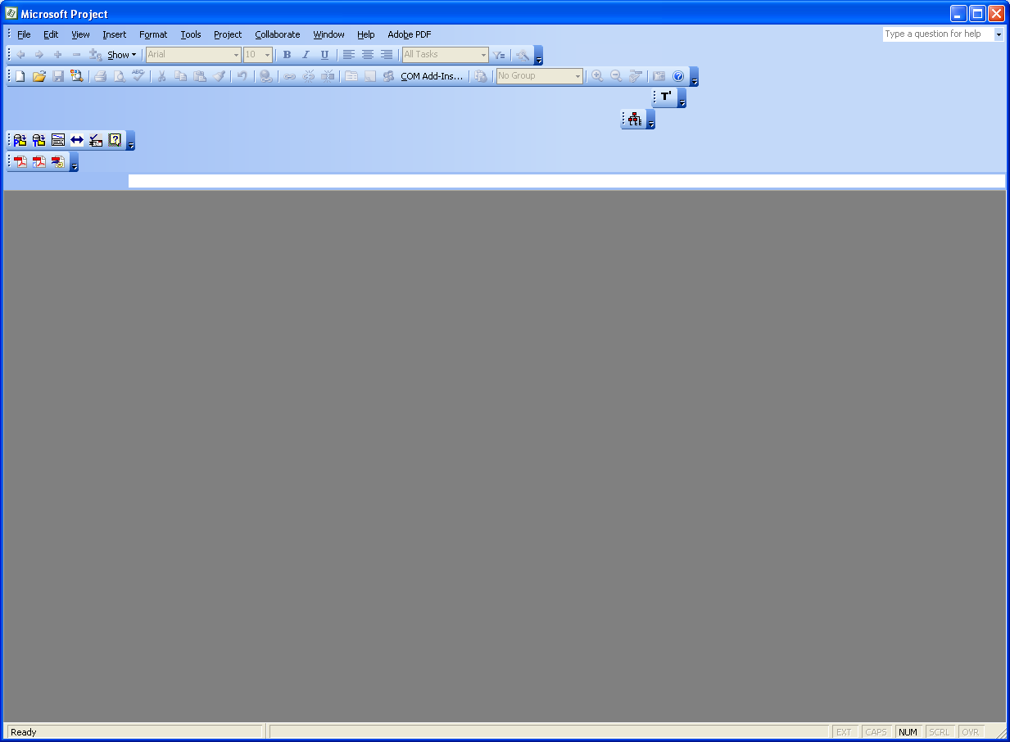

- Import the project into the MS Project Enterprise database

Select Tools-> Enterprise Options -> Import Project to Enterprise. The following screen should appear:

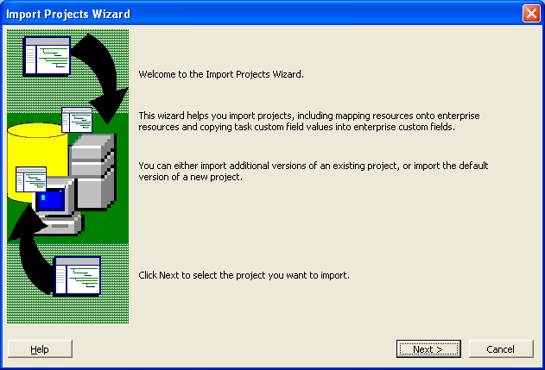

Press Next then select the project you wish to import (the same as above, hopefully!) and click on the Import button:

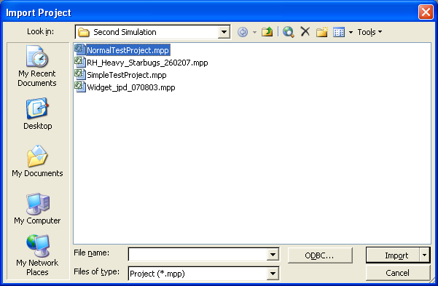

Until we get the currency stuff sorted out you may get the following warning message. If you do then just click Yes:

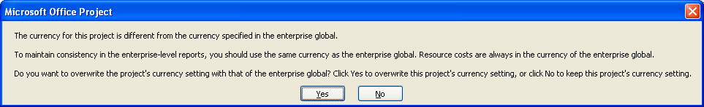

The following screen should appear:

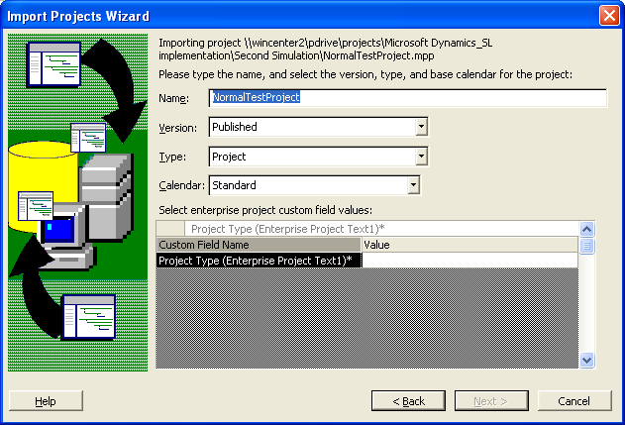

Make sure that the name in the Name: field is what you want. Once you have named the project here it will be impossible to change the name.

Leave the Version: field the same.

Leave the Type: field the same.

Change the Calendar: field to AAO Calendar

In the Custom Field Name Value field select the type of project… Internal for AAO internal projects, External for externally funded projects, Administrative for administrative projects such as leave, and Testing for test projects that are only used to test the system.
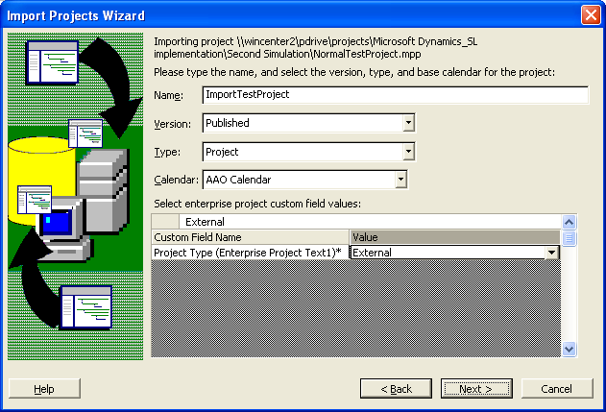

Then click on the Next > button. The following screen should appear:

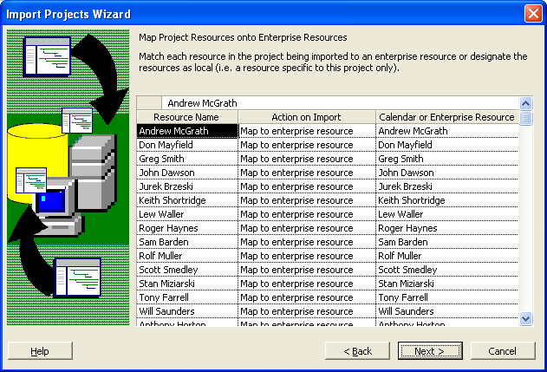

Check to insure that all of the AAO Resource Names in your project map to Enterprise Resources of the same name. If you have local resources such as vendors they will be imported as local resources for your project, so this is ok…

If a resource does not match (you spelled the name wrong or something like that) then choose the enterprise resource you want to be associated with the project resource by selecting it via the pull-down menu on the resource name in the Calendar or Enterprise Resource field.

When you are happy that all resources are correct then click on the Next > button. The following screen should appear:

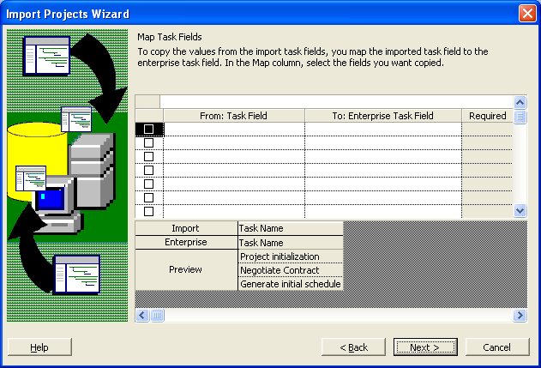

Just click the Next > button, this will bring up the pre-import checking error reporting screen:

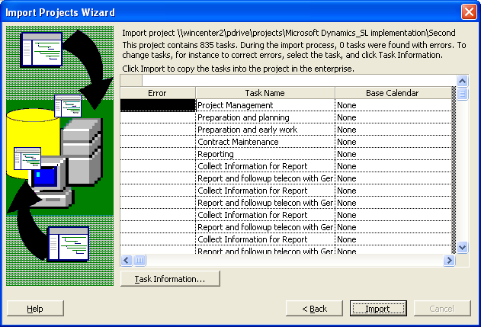

Hopefully there are no errors! I think it is possible to fix them with the Task Information button but I have never tried this… When there are no errors press the Import button. Once you do this there is no going back… the import process will start and when it is done you the following screen should appear:

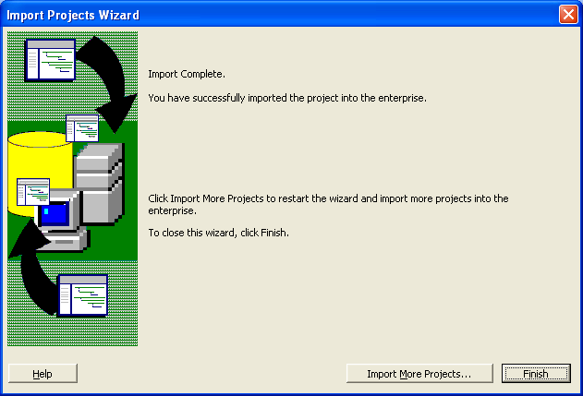

Click the Finish button unless you want to import another project. The import is now complete and the project screen looks like:

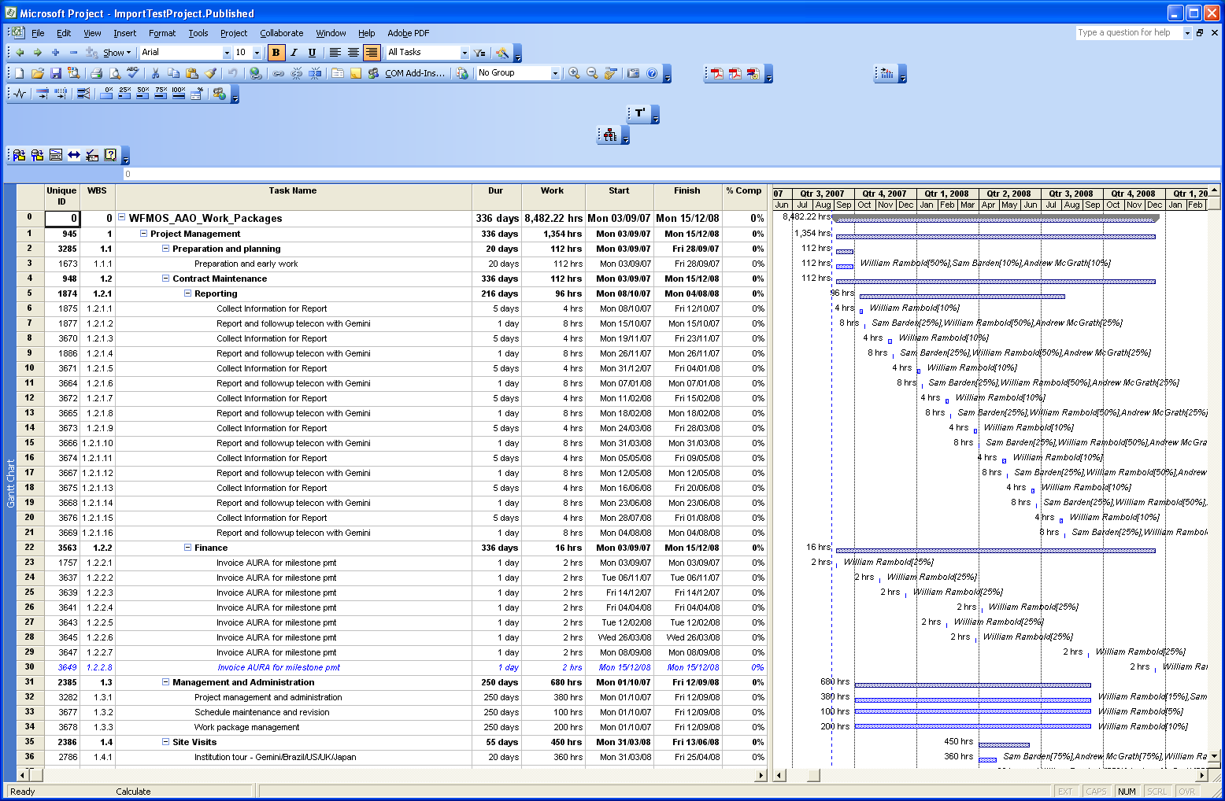

Note that the project now has .Published after the name.

Push the save button … the project is now in the MS Project Server database and is ready for import to Solomon.

See “Importing MSP Server Projects to Solomon” for the instructions on how to import the project into the Solomon system.

