Importing MSP Server Projects into Solomon.

2007/08/28 WNR

- Open the project to be imported if it is not already open.

File->Open then select the project and press the Open button.

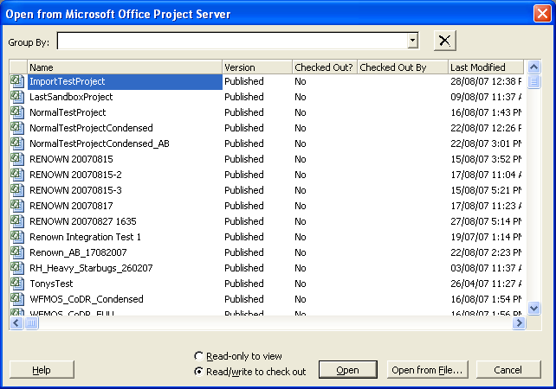

The project should appear with .Published after its name in the title bar:

If this is the first time the project has been opened in server there will be some error/warning messages to deal with first. These will go away when a proper project template is created. For now, just get rid of them…

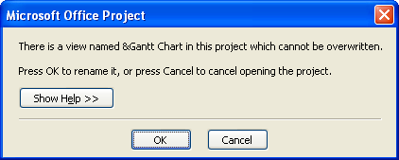

Press OK then rename &Gantt Chart to &Gantt Chart Old

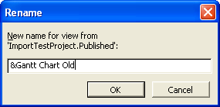

Press OK

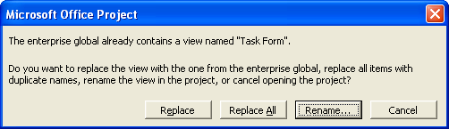

Press Replace All

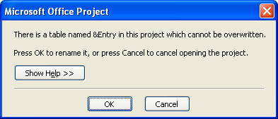

Press OK then rename &Entry to &Entry Old and click OK.

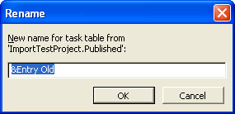

Now you should see the project:

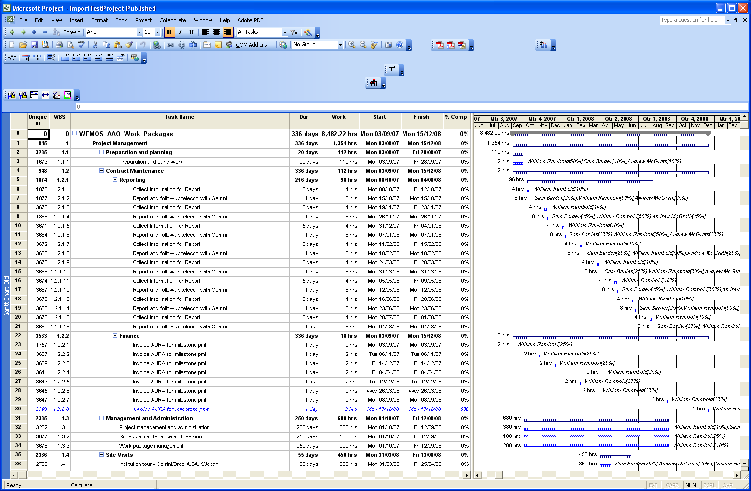

- Prepare the project for import into Solomon.

Display (insert) the following two columns before the Duration column:

Enterprise Flag 20 – Integration Level
Enterprise Flag 19 – Exclude from Integration

The View should look like

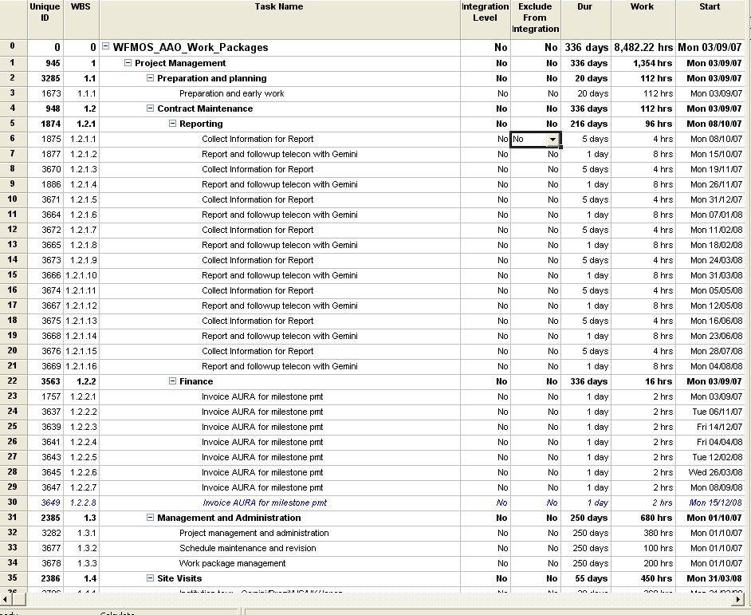

By default all tasks except milestones and tasks with no work assigned will be imported to Solomon. Summary tasks will be imported as well.

To prevent a given task from being imported into Solomon set the “Exclude from Integration” flag to “Yes”.

It is possible to perform the Solomon Integration at a higher level than the normal task level. This allows time to be booked to logical “summary” tasks instead of the lowest level tasks. All resource assignments below the “summary” level will be rolled up into the summary when the project is imported to Solomon. Any changes to the low level tasks after that will propagate to Solomon via the summary level task. From this point on Solomon will teat the summary in the same way as it treats the low level tasks in the project.

To identify a summary as an “integration level” task set the “Integration Level” flag for the summary task to “Yes”.

For example, in the project we have imported…

Before the integration level is changed:

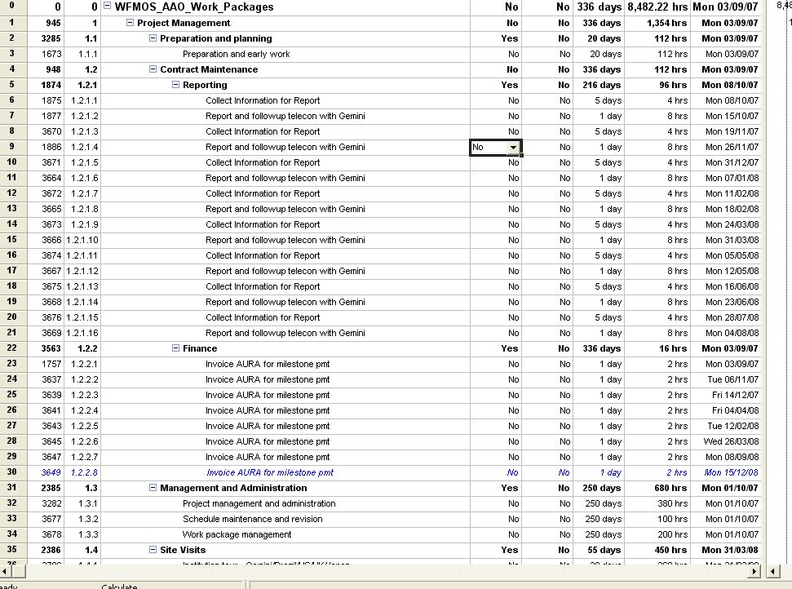

After the integration level is changed

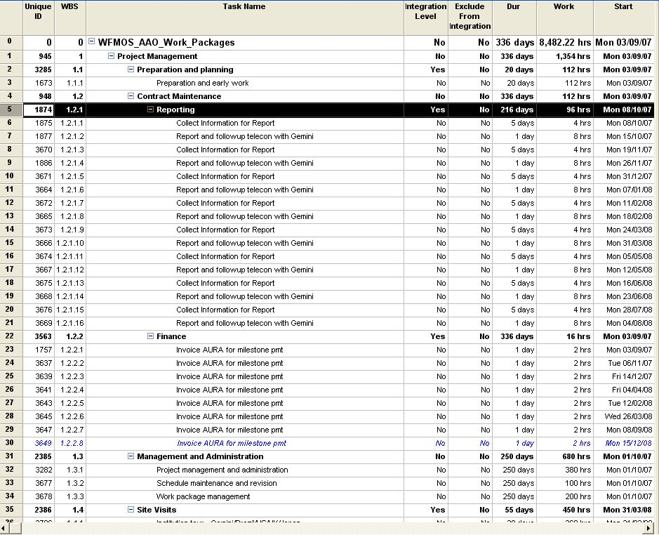

For example, setting the integration level of task 5 to Yes means that tasks number 6 through 21 are not imported to Solomon. All of the resource assignments for tasks 6 through 21 are rolled up into task 5. In Solomon, task 5 is treated as a low-level task.

The same happens with task 22, which is now a rollup of tasks 23 through 30.

Note that task 31 is not a rollup so tasks 32 through 34 are imported and synchronized in Solomon.

This feature is used to simplify the Solomon WBS structure (usually to three levels) for time entry, financial tracking and project reporting purposes.

- Import the project into Solomon.

When the integration level has been defined for the entire project and the excluded tasks identified the project can be loaded into Solomon.

It might look something like this now…

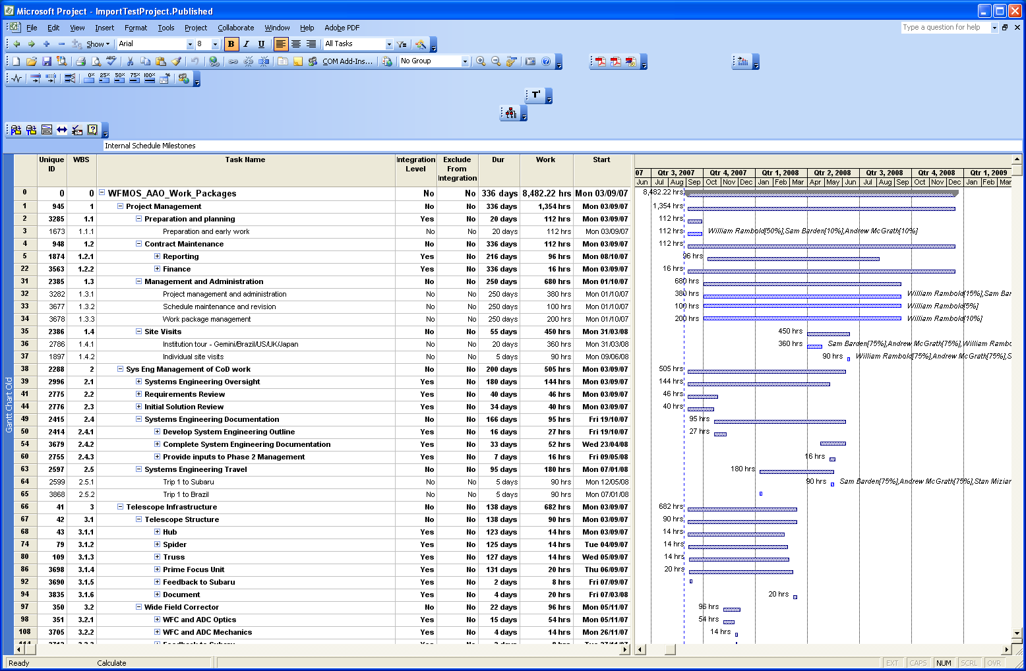

Press the Solomon Import button:

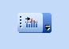

The following screen should appear.

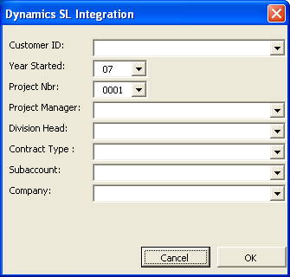

Define the Solomon Project Identifier (must not be the same as an existing Solomon project ID) by choosing the Customer ID, the Year Started and the Project Number. Assign the project manager and the Division Head. Set the Contract Type to Fixed Price to WIP (FPW) and select the default account code which is 910 for all projects. Finally select the company, which is AAO … You must seek approval of the project code number from the Head of Instrumentation. Approved code numbers can be found at http://www2.aao.gov.au/twiki/pub/BusinessPractices/ImportingNewProjects/Project_Codes_070919.pdf . The Project Nbr in the Integration window must contain an A, I, or X followed by the 3 digit number given for your project.

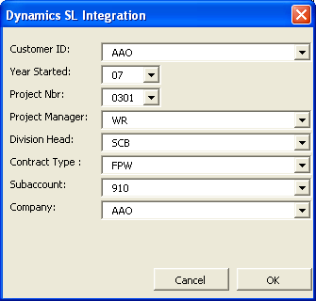

Then press OK This tells the server that this is a Solomon project and should be synchronized with the Solomon Database whenever the project is saved.

Then press the save button… this creates the project in Solomon and does an initial synchronization.

- Confirm that the project was imported successfully.

Open Solomon

Project Controller -> Project maintenance then F3 in the Project Field

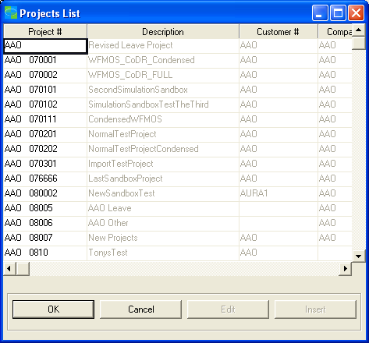

Yes, project ID AAO 070301 has appeared!

Select the project and look at the detail screen, it has been created and is already active…

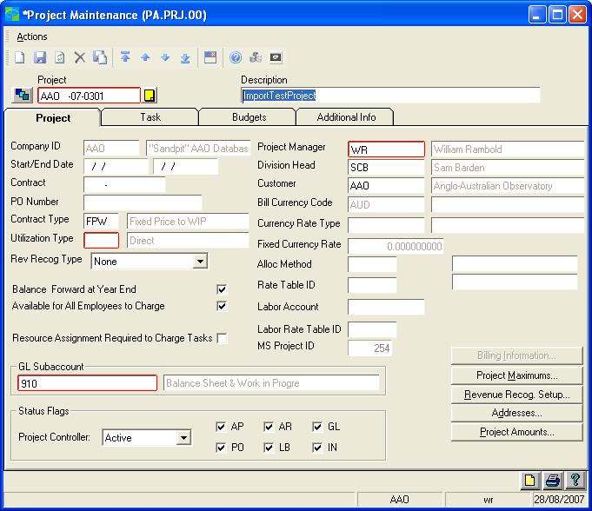

- Confirm that the “Available for All Employees to Charge” option is checked.
- Confirm that the “Resource Assignment Required to Charge Tasks” option is not checked.
- Confirm that the GL Subaccount is 910.
- Confirm that the Project Controller Status Flag is set to Active.
- Select DIR in the Utilisation Type field.

Press the Save button to update the project information.

Select the Tasks Tab to confirm that the rolled-up tasks were imported properly:

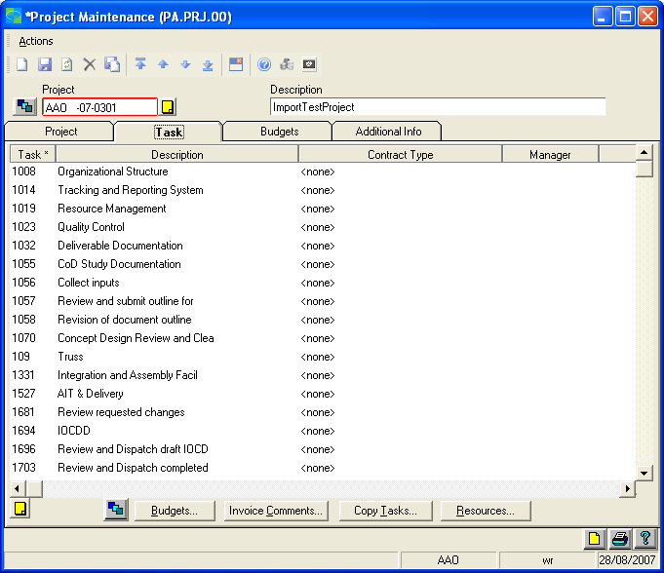

- Clean up the MSP Server project after import to Solomon.

In the MSP Server project Gantt Chart view hide the two Solomon synchronisation columns so they can not be changed accidentally now that the project has been synchronised with Solomon.

Note that from this point on you can NOT delete tasks in the MSP Server project and you can not change the way tasks are rolled-up into Solomon Summary tasks.

Save the project in MSP Server…

And the process is complete. From now on any changes made to the MS Project will be reflected in Solomon whenever the project is saved in MS Project.

Now the project has been loaded into Solomon see the “Importing MS Server Project Budgets to Solomon” document for instructions on loading the project task budgets into Solomon.

