Importing MSP Server Project Budgets into Solomon.

2007/08/28 WNR

- Open the project to be imported if it is not already open.

File->Open then select the project and press the Open button.

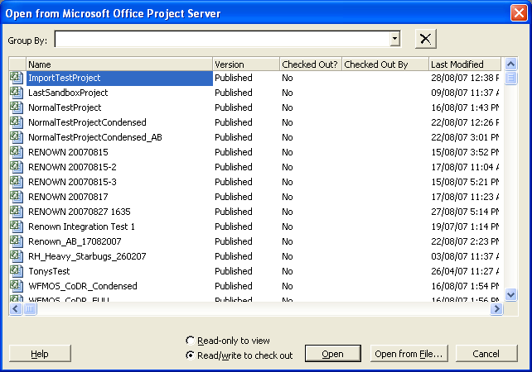

The project should appear with .Published after its name in the title bar:

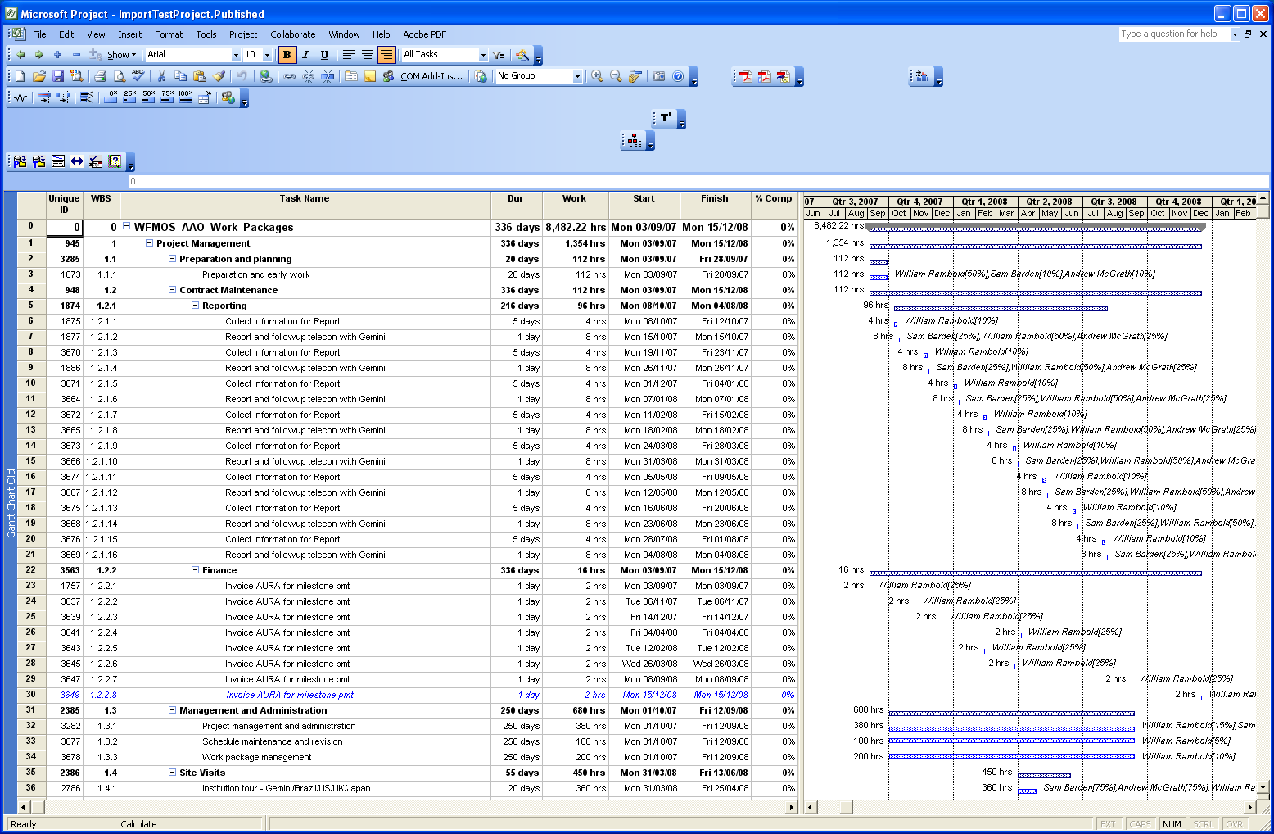

- Prepare the project baseline for import into Solomon.

Tools->Tracking->Save Baseline: Save a baseline as “Baseline 1”

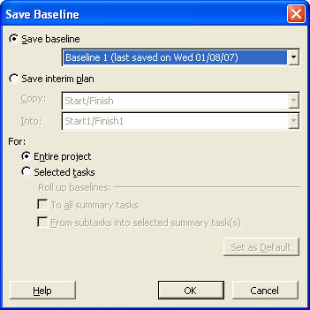

Then press the save button…

- Import the project budget into Solomon.

Open the Project Budgeting Screen in Solomon

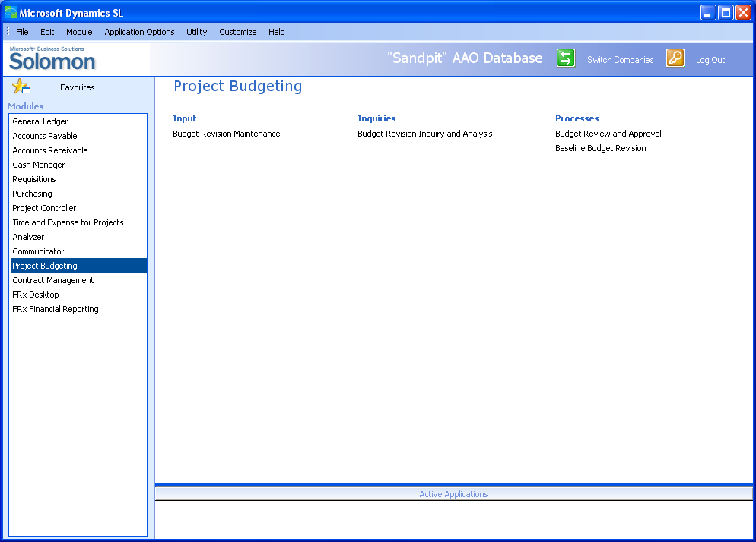

Select the Baseline Budget Revision screen

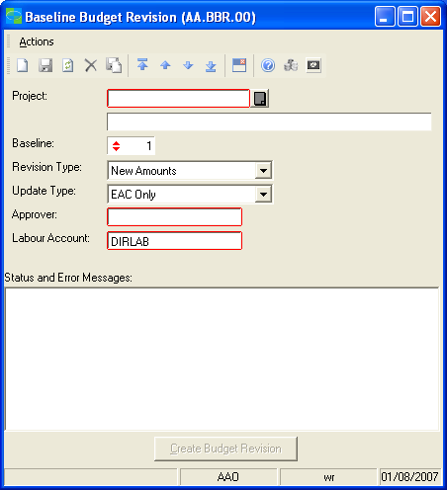

Select the project budget to import. Make sure that the Baseline number is the same as the baseline you saved in MS project! Select New Amounts; Original Budget & EAC & FAC; choose who gets to approve the budget; and make sure the Labour Account is DIRLAB.

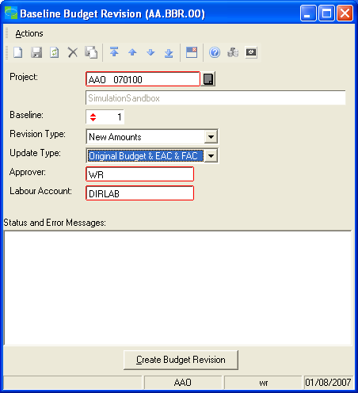

Press the Create Budget Revision button

Nothing will happen for a while, then the status screen should say “Revision xxxx Created”.

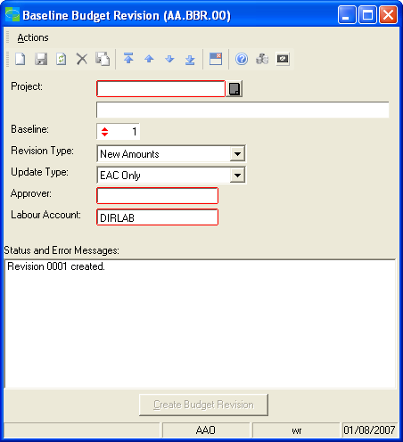

Check in Solomon to make sure that the budget was created properly…

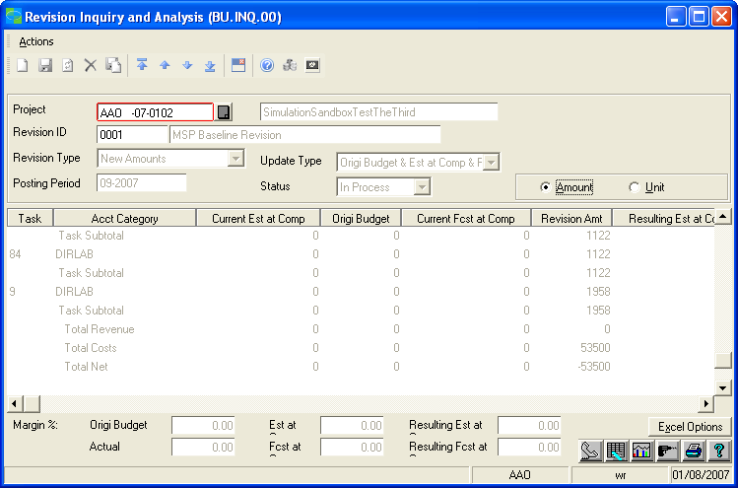

The number at the bottom for Total Costs should be close to the total labour cost shown in MS Project (not exactly, some rounding is done and the labour rate tables are not the same at the moment…).

If you select Unit instead of Amount then the number at the bottom for Total Costs should be the same as the Work number in MS Project.

Add Non-Labour resources ….

The following is the WBS and budget breakdown table for the simulation sandbox…
Select the Budget Revision Maintenance form…

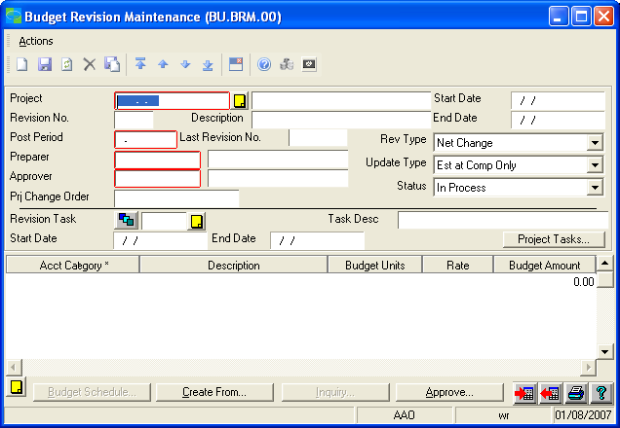

Select the project you have just created a budget for and revision 1, the budget you have just created…

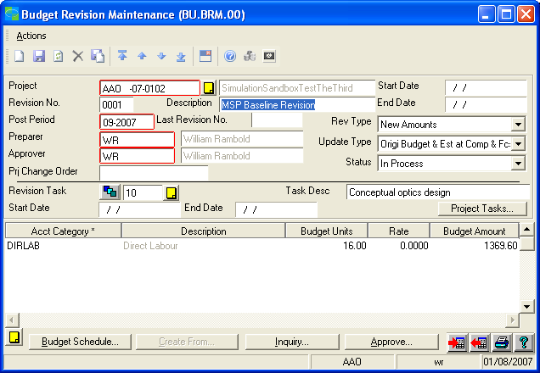

Then, on a task-by-task basis enter the non-labour budget items.

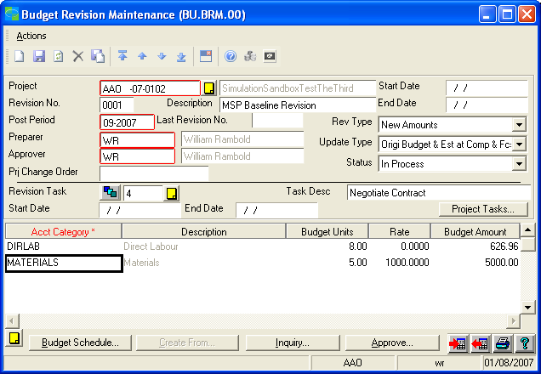

Remember to press save after each budget entry is made…

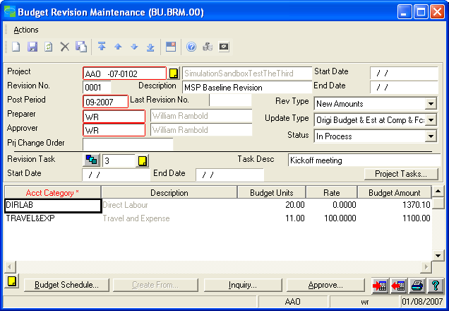

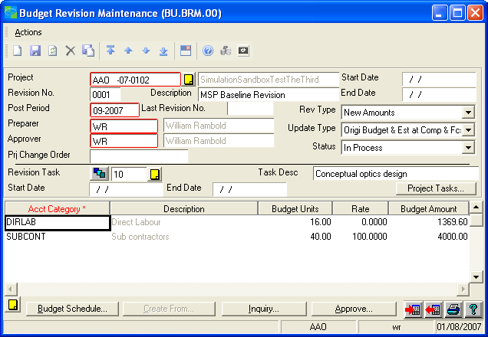

When all of the budget items are complete change the status from “In Process” to “Completed” and press the save button.

The budget is now ready to be approved by the person identified as the “Approver” for this budget.….

